Projects: Set-1
- Task & Project Management: Employee Task Assignment System
- Smart Campus: Student Admission Service
- Healthcare: Hospital Appointment System
- E-Commerce: Online Shopping Platform
- Banking & Finance: Online Banking System
- Library & Learning: Library Book Management System
- Transport: Bus Tracking System
- Food & Delivery: Online Food Ordering System
- Recruitment & HR: Online Recruitment Portal
- Agriculture: Farmer Support Platform
- Insurance: Health Insurance Management System
- Event Management: College Event Management System
- Learning Management: Online Learning Management System
- Smart City: Citizen Complaint Management System
- Cybersecurity: Secure User Registration and Login System
- Task & Project Management: Student Project Tracking System
- Smart Campus: Course Registration System
- Healthcare: Patient Record Management System
- E-Commerce: Product Catalogue Management System
- Banking & Finance: Customer Account Management System
- Library & Learning: Book Borrowing and Return System
- Transport: Cab Booking System
- Food & Delivery: Restaurant Table-Booking System
- Recruitment & HR: Resume Management System

Projects: Set-2
- Agriculture: Crop Recommendation System
- Insurance: Vehicle Insurance Management System
- Event Management: Conference Registration System
- Learning Management: Student Course Recommendation System
- Smart City: Municipal Service Request System
- Cybersecurity: Multi-Factor Authentication System
- Task & Project Management: Faculty Workload Management System
- Smart Campus: Faculty Management System
- Healthcare: Doctor Availability System
- E-Commerce: Order Processing System
- Banking & Finance: Fund Transfer System
- Library & Learning: Digital Library Platform
- Transport: Vehicle Rental System
- Food & Delivery: Food Delivery Tracking System
- Recruitment & HR: Interview Scheduling System
- Agriculture: Agricultural Equipment Rental System
- Insurance: Life Insurance Management System
- Event Management: Seminar Management System
- Learning Management: Virtual Classroom System
- Smart City: Waste Collection Management System
- Cybersecurity: Role-Based Access Control Management System
- Task & Project Management: Software Bug Tracking System
- Smart Campus: Attendance Management System
- Healthcare: Pharmacy Management System

Projects: Set-3

- E-Commerce: Shopping Cart Service
- Banking & Finance: Personal Loan Management System
- Library & Learning: E-Book Subscription System
- Transport: Campus Transport System
- Food & Delivery: Cloud-Kitchen Management System
- Recruitment & HR: Employee Onboarding System
- Agriculture: Fertilizer Management System
- Insurance: Travel Insurance Management System
- Event Management: Workshop Booking System
- Learning Management: Online Assignment Management System
- Smart City: Streetlight Complaint System
- Cybersecurity: Digital Identity Verification System
- Task & Project Management: Research Project Monitoring System
- Smart Campus: Examination Management System
- Healthcare: Laboratory Test Booking System
- E-Commerce: Payment Management System
- Banking & Finance: Education Loan Processing System
- Library & Learning: Book Recommendation System
- Transport: School Bus Monitoring System
- Food & Delivery: Grocery Ordering System
- Recruitment & HR: Employee Attendance System
- Agriculture: Seed Distribution System
- Insurance: Property Insurance System
- Event Management: Wedding Event Management System
Projects: Set-4

- Learning Management: Online Quiz System
- Smart City: Water-Supply Complaint System
- Cybersecurity: Password Security and Account Recovery System
- Task & Project Management: Team Collaboration Platform
- Smart Campus: Student Result Processing System
- Healthcare: Blood Bank Management System
- E-Commerce: Inventory Management System
- Banking & Finance: Home Loan Management System
- Library & Learning: Library Fine Management System
- Transport: Fleet Management System
- Food & Delivery: Canteen Management System
- Recruitment & HR: Leave Management System
- Agriculture: Crop Disease Reporting System
- Insurance: Insurance Policy Recommendation System
- Event Management: Cultural Programme Management System
- Learning Management: Coding Assessment Platform
- Smart City: Property-Tax Payment System
- Cybersecurity: Security Incident Reporting System
- Task & Project Management: Agile Sprint Management System
- Smart Campus: Fee Payment Management System
- Healthcare: Ambulance Booking System
- E-Commerce: Product Recommendation System
- Banking & Finance: Credit Card Management System
- Library & Learning: Research Paper Repository
Projects: Set-5
- Transport: Vehicle Service Booking System
- Food & Delivery: Hostel Mess Management System
- Recruitment & HR: Payroll Management System
- Agriculture: Farm Labour Management System
- Insurance: Premium Payment System
- Event Management: Sports Event Management System
- Learning Management: Student Attendance Analytics System
- Smart City: Birth-Certificate Request System
- Cybersecurity: Vulnerability Tracking and Remediation System
- Task & Project Management: Assignment Submission Tracker
- Smart Campus: Hostel Management System
- Healthcare: Medical Insurance Verification System
- E-Commerce: Customer Review Management System
- Banking & Finance: Digital Wallet System
- Library & Learning: Online Quiz Platform
- Transport: Parking Management System
- Food & Delivery: Recipe Recommendation System
- Recruitment & HR: Employee Training System
- Agriculture: Agricultural Marketplace
- Insurance: Insurance Claim Processing System
- Event Management: Hackathon Management Platform
- Learning Management: Learning Progress Monitoring System
- Smart City: Death-Certificate Request System
- Cybersecurity: Phishing Awareness and Reporting Platform

Projects: Set-6

- Task & Project Management: Daily Work Reporting System
- Smart Campus: Campus Transport Management System
- Healthcare: Hospital Bed Allocation System
- E-Commerce: Delivery Tracking System
- Banking & Finance: Fixed-Deposit Management System
- Library & Learning: Course Content Management System
- Transport: Traffic Violation Management System
- Food & Delivery: Restaurant Review Platform
- Recruitment & HR: Performance Appraisal System
- Agriculture: Irrigation Scheduling System
- Insurance: Claim Document Verification System
- Event Management: Technical-Fest Management System
- Learning Management: Faculty Course Management System
- Smart City: Public-Grievance Tracking System
- Cybersecurity: Secure Document-Sharing System
- Task & Project Management: Project Deadline Reminder System
- Smart Campus: Placement Management System
- Healthcare: Vaccination Management System
- E-Commerce: Return and Refund Management System
- Banking & Finance: Expense Tracking System
- Library & Learning: Student Assignment Portal
- Transport: Fuel Consumption Tracking System
- Food & Delivery: Catering Booking System
- Recruitment & HR: Employee Grievance System
Projects: Set-7
- Agriculture: Farmer Loan Management System
- Insurance: Insurance Agent Management System
- Event Management: Alumni Meet Management System
- Learning Management: Student Mentoring System
- Smart City: Emergency-Service Management System
- Cybersecurity: Network Access Request Management System
- Task & Project Management: Helpdesk Ticket Management System
- Smart Campus: Alumni Management System
- Healthcare: Telemedicine Consultation System
- E-Commerce: Coupon Management System
- Banking & Finance: EMI Calculation and Payment System
- Library & Learning: Faculty Material-Sharing System
- Transport: Driver Duty Scheduling System
- Food & Delivery: Meal Subscription System
- Recruitment & HR: Internal Job-Posting System
- Agriculture: Crop Insurance System
- Insurance: Customer Policy Portal
- Event Management: Corporate Event Management System
- Learning Management: Adaptive Learning Platform
- Smart City: Smart Parking Management System
- Cybersecurity: API Security Monitoring System
- Task & Project Management: Maintenance Request Tracking System
- Smart Campus: Scholarship Management System
- Healthcare: Medicine Reminder System

Projects: Set-8
- E-Commerce: Seller Management Platform
- Banking & Finance: Fraud Alert Management System
- Library & Learning: Online Examination System
- Transport: Logistics Transport Management System
- Food & Delivery: Diet-Plan Management System
- Recruitment & HR: Freelancer Hiring Platform
- Agriculture: Weather Advisory Management System
- Insurance: Insurance Renewal Reminder System
- Event Management: Event Ticket Booking System
- Learning Management: Examination Preparation System
- Smart City: Public-Transport Information System
- Cybersecurity: Audit Log Management System
- Task & Project Management: Meeting Action-Item Tracker
- Smart Campus: Classroom Allocation System
- Healthcare: Patient Feedback System
- E-Commerce: Wholesale Ordering System
- Banking & Finance: Insurance Premium Payment System
- Library & Learning: Question Bank Management System
- Transport: Courier Tracking System
- Food & Delivery: Food Inventory Management System
- Recruitment & HR: Internship Management System
- Agriculture: Farm Expense Tracking System
- Insurance: Claim Status Tracking System
- Event Management: Venue Booking System

Projects: Set-9
- Learning Management: Digital Certification Platform
- Smart City: Government Scheme Information System
- Cybersecurity: Cybersecurity Training and Assessment Platform
- Task & Project Management: Internship Progress Monitoring System
- Smart Campus: Laboratory Booking System
- Healthcare: Emergency Case Management System
- E-Commerce: Electronics Shopping Platform
- Banking & Finance: Mutual-Fund Investment Tracker
- Library & Learning: Student Learning Progress Tracker
- Transport: Vehicle Insurance Reminder System
- Food & Delivery: Bakery Ordering System
- Recruitment & HR: Skill-Matching Recruitment System
- Agriculture: Soil-Test Management System
- Insurance: Accident Claim Management System
- Event Management: Event Volunteer Management System
- Learning Management: Academic Project Management System
- Smart City: Community Hall Booking System
- Cybersecurity: Data-Privacy Consent Management System
- Task & Project Management: Employee Performance Tracking System
- Smart Campus: Faculty Leave Management System
- Healthcare: Health Check-up Package System
- E-Commerce: Fashion Shopping Platform
- Banking & Finance: Bank Complaint Management System
- Library & Learning: Certification Management System

Projects: Set-10
- Transport: Carpooling Platform
- Food & Delivery: Farmer-to-Customer Food Platform
- Recruitment & HR: Employee Shift Scheduling System
- Agriculture: Dairy Farm Management System
- Insurance: Hospital Insurance Approval System
- Event Management: Event Sponsorship Management System
- Learning Management: Student Discussion Forum
- Smart City: Public-Hospital Appointment System
- Cybersecurity: Secure File-Integrity Monitoring System
- Task & Project Management: Laboratory Task Management System
- Smart Campus: Student Grievance System
- Healthcare: Medical Equipment Tracking System
- E-Commerce: Grocery Delivery System
- Banking & Finance: ATM Service Monitoring System
- Library & Learning: Virtual Laboratory Booking System
- Transport: Emergency Vehicle Dispatch System
- Food & Delivery: Food Donation Management System
- Recruitment & HR: Employee Document Management System
- Agriculture: Poultry Farm Management System
- Insurance: Crop Insurance Management System
- Event Management: Event Catering Coordination System
- Learning Management: Peer Evaluation System
- Smart City: Electricity Complaint Management System
- Cybersecurity: Threat Alert and Notification System

Projects: Set-11
- Task & Project Management: Event Task Coordination System
- Smart Campus: Campus Visitor Management System
- Healthcare: Nurse Duty Scheduling System
- E-Commerce: Book Shopping Platform
- Banking & Finance: KYC Verification Workflow
- Library & Learning: Coding Practice Platform
- Transport: Public Transport Pass System
- Food & Delivery: Kitchen Order Display System
- Recruitment & HR: Background Verification Workflow
- Agriculture: Fish-Farm Management System
- Insurance: Insurance Complaint System
- Event Management: Speaker Management System
- Learning Management: Course Feedback Management System
- Smart City: Road-Damage Reporting System
- Cybersecurity: Device Registration and Access Management System
- Task & Project Management: Construction Project Tracker
- Smart Campus: Certificate Request System
- Healthcare: Organ Donation Management System
- E-Commerce: Furniture Marketplace
- Banking & Finance: Transaction Limit Management System
- Library & Learning: Academic Discussion Forum
- Transport: Route Planning System
- Food & Delivery: Restaurant Staff Scheduling System
- Recruitment & HR: Employee Exit Management System

Projects: Set-12
- Agriculture: Organic Farming Marketplace
- Insurance: Policy Comparison Platform
- Event Management: Event Feedback System
- Learning Management: Online Laboratory Management System
- Smart City: Disaster-Relief Management System
- Cybersecurity: Privileged Account Management System
- Task & Project Management: Marketing Campaign Task Manager
- Smart Campus: Student Mentoring System
- Healthcare: Diagnostic Report Management System
- E-Commerce: Handicraft Marketplace
- Banking & Finance: Bank Branch Appointment System
- Library & Learning: Student Doubt-Management System
- Transport: Toll Payment Management System
- Food & Delivery: Food Coupon Management System
- Recruitment & HR: Employee Reward System
- Agriculture: Warehouse Storage Management System
- Insurance: Risk Assessment Workflow
- Event Management: Event Certificate Generation System
- Learning Management: Academic Calendar Management System
- Smart City: Citizen Document Verification System
- Cybersecurity: Security Policy Compliance Tracker
- Task & Project Management: Hospital Staff Task Management System
- Smart Campus: Campus Event Management System
- Healthcare: Rural Healthcare Support System

Projects: Set-14
- E-Commerce: Subscription-Commerce System
- Banking & Finance: Microfinance Management System
- Library & Learning: Digital Notes Management System
- Transport: Vehicle Breakdown Assistance System
- Food & Delivery: Corporate Lunch Booking System
- Recruitment & HR: Team Resource Allocation System
- Agriculture: Crop Transportation System
- Insurance: Fraudulent Claim Alert System
- Event Management: Exhibition Management System
- Learning Management: Student Skill Tracking System
- Smart City: Local-Business Registration System
- Cybersecurity: Digital Certificate Management System
- Task & Project Management: Personal Productivity Management System
- Smart Campus: Library Fine Management System
- Healthcare: Mental-Wellness Appointment System
- E-Commerce: Auction Management Platform
- Banking & Finance: Savings Goal Management System
- Library & Learning: Peer-Learning Platform
- Transport: Delivery-Vehicle Tracking System
- Food & Delivery: Food Waste Tracking System
- Recruitment & HR: Workforce Analytics System
- Agriculture: Government Subsidy Tracking System
- Insurance: Insurance Surveyor Management System
- Event Management: Training Event Management System

Projects: Set-15
- Learning Management: Faculty Appointment Booking System
- Smart City: Public-Safety Alert System
- Cybersecurity: Fraudulent Login Detection System
- Task & Project Management: Customer Complaint Tracking System
- Smart Campus: Faculty Appraisal System
- Healthcare: Home Healthcare Booking System
- E-Commerce: Price Comparison System
- Banking & Finance: Merchant Payment System
- Library & Learning: Educational Video Platform
- Transport: Travel Ticket Booking System
- Food & Delivery: Healthy Meal Ordering System
- Recruitment & HR: Employee Helpdesk System
- Agriculture: Agricultural Training Platform
- Insurance: Corporate Insurance Management System
- Event Management: Webinar Management System
- Learning Management: Learning Resource Recommendation System
- Smart City: Government Office Appointment System
- Cybersecurity: Secure Visitor Access Management System
- Task & Project Management: DevOps Incident Management System
- Smart Campus: College Asset Management System
- Healthcare: Hospital Billing System
- E-Commerce: Customer Loyalty Management System
- Banking & Finance: Financial Approval Workflow
- Library & Learning: Training Programme Management System

Projects: Set-16
- Transport: Railway Enquiry Management System
- Food & Delivery: Campus Food Pre-Ordering System
- Recruitment & HR: Recruitment Approval Workflow
- Agriculture: Farmer Complaint Management System
- Insurance: Policy Cancellation System
- Event Management: Event Equipment Booking System
- Learning Management: Internship Learning Portal
- Smart City: Pollution Complaint System
- Cybersecurity: Backup and Recovery Request System
- Task & Project Management: Examination Work Allocation System
- Smart Campus: Online Academic Advising System
- Healthcare: Disease-Symptom Information System
- E-Commerce: Warehouse Order Fulfilment System
- Banking & Finance: Secure Bill Payment System
- Library & Learning: Skill Assessment System
- Transport: Smart Bicycle Rental System
- Food & Delivery: Event Food Management System
- Recruitment & HR: Campus Placement Recruitment System
- Agriculture: Agricultural Produce Auction System
- Insurance: Insurance Customer Support System
- Event Management: Event Expense Management System
- Learning Management: Competitive Examination Practice System
- Smart City: Smart City Asset Management System
- Cybersecurity: Cybersecurity Helpdesk Ticketing System

AI tools students should use in every project
Students should use mandatory 5 AI tools in every project where necessary
Each batch can use the tools in the following project stages:
Project stage | AI/tool
Requirement understanding | ChatGPT or Gemini Notebook
User stories and sprint planning | Jira
SOA and microservices diagram | Lucidchart AI
Spring Boot coding | GitHub Copilot
REST API testing | Postman Agent Mode
Security analysis | Semgrep
Unit-test generation | GitHub Copilot
CI/CD | GitHub Actions

Common project architecture
Every project should contain approximately four services:
Sample Architecture to be followed: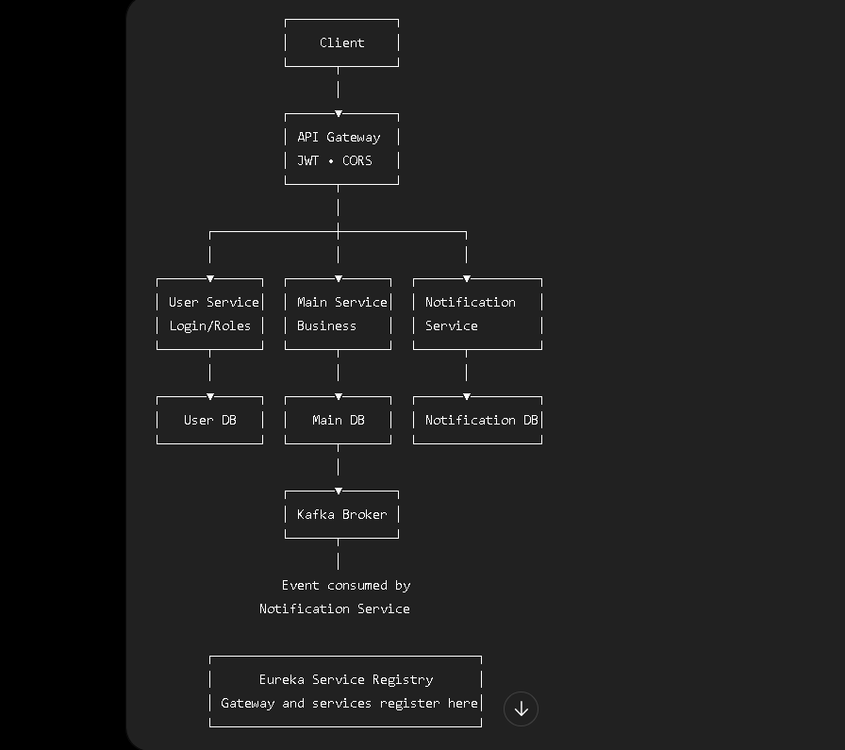

Students should demonstrate:
- Service contracts and endpoints
- REST APIs
- At least three microservices
- JWT authentication and role-based authorization
- CORS configuration
- Eureka service registration
- Spring Cloud Gateway routing
- Database per service
- Unit and integration tests
- Postman API testing
- GitHub Actions
- Jira user stories and sprint board
- Architecture diagram created using an AI diagram tool

